ASSIGNMENT-DIGITAL MARKETING

|  |  |
| --- | --- |
| Reg No | 960220106074 |
| Team ID | NM2023TMID09736 |
| NM ID | 50D3EF6584CEBFEA20546B41FA0D170F |
| Date | 20-10-2023 |

|  |  |  |
| --- | --- | --- |
|  |  |  |

1.Create a blog or website using Blogspot and WordPress. Customize the theme design and post new article with 500 words.

Link: <https://www.blogger.com/blog/posts/4906561961716911169>

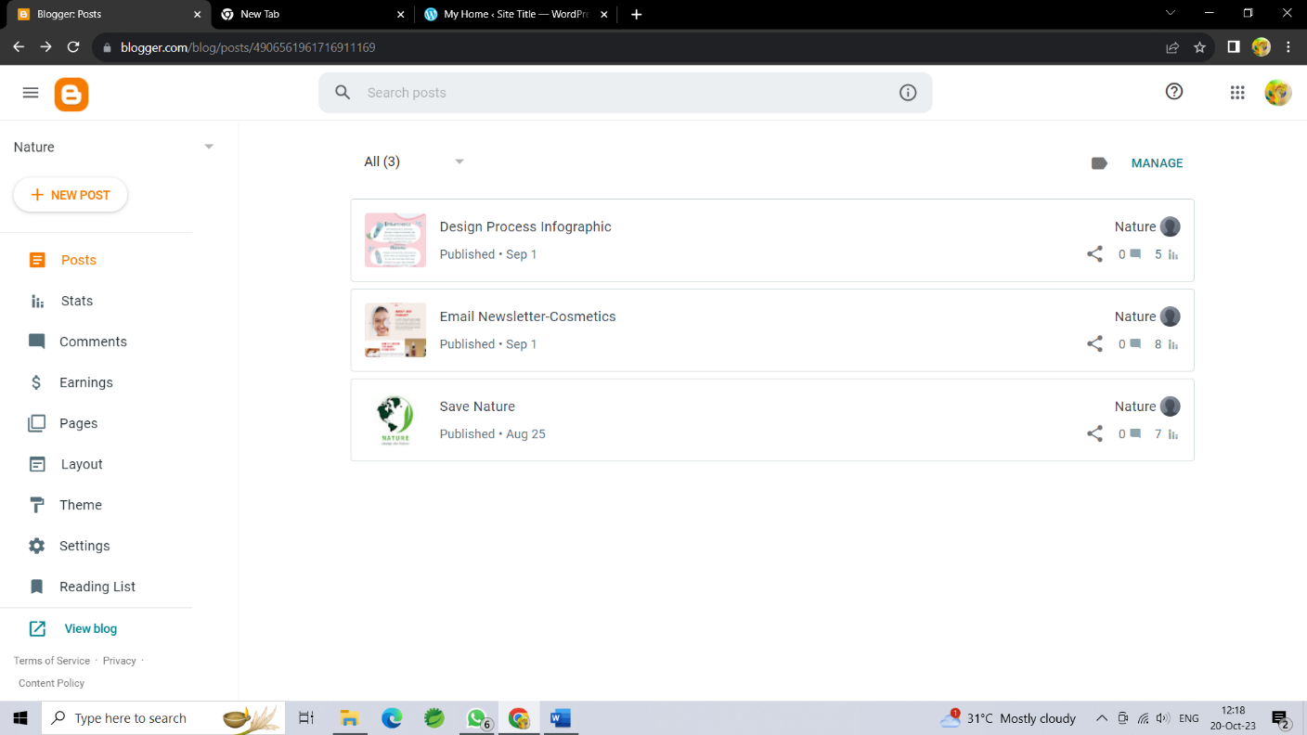

Link: <https://www.blogger.com/blog/post/edit/4906561961716911169/8614934479698548073>

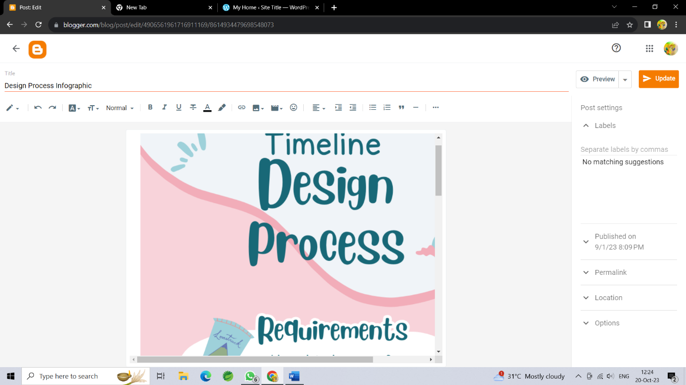

Link: <https://wordpress.com/home/224914933?showLaunchpad=true>

Link: <https://aboutcosmetics1602.wordpress.com/2023/10/06/cosmetics/>

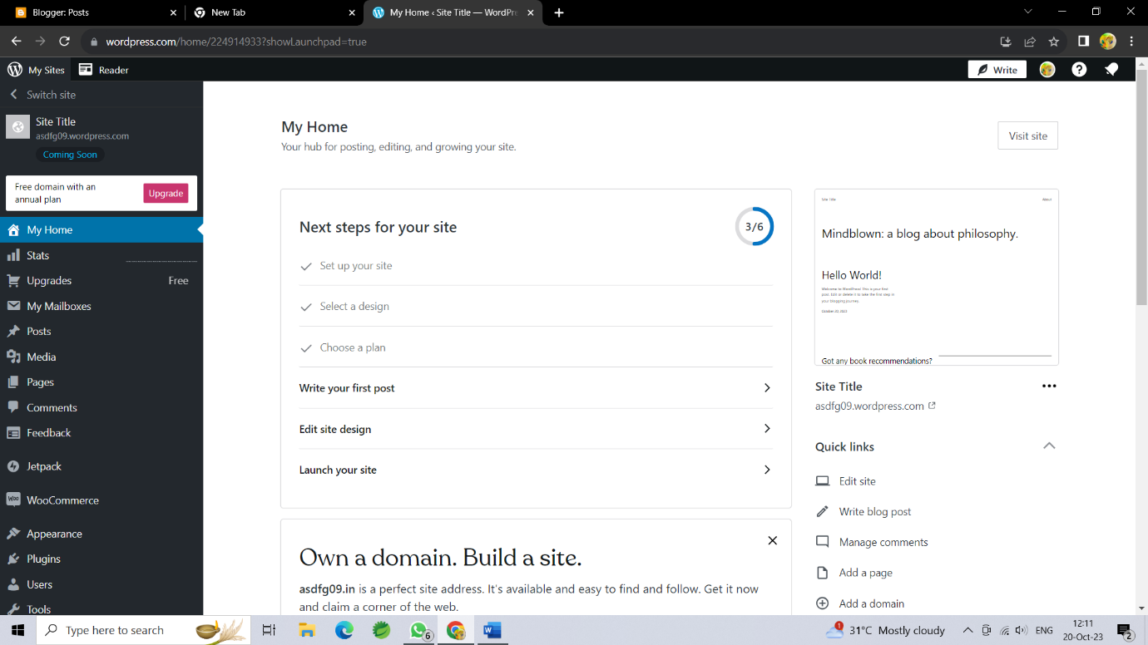

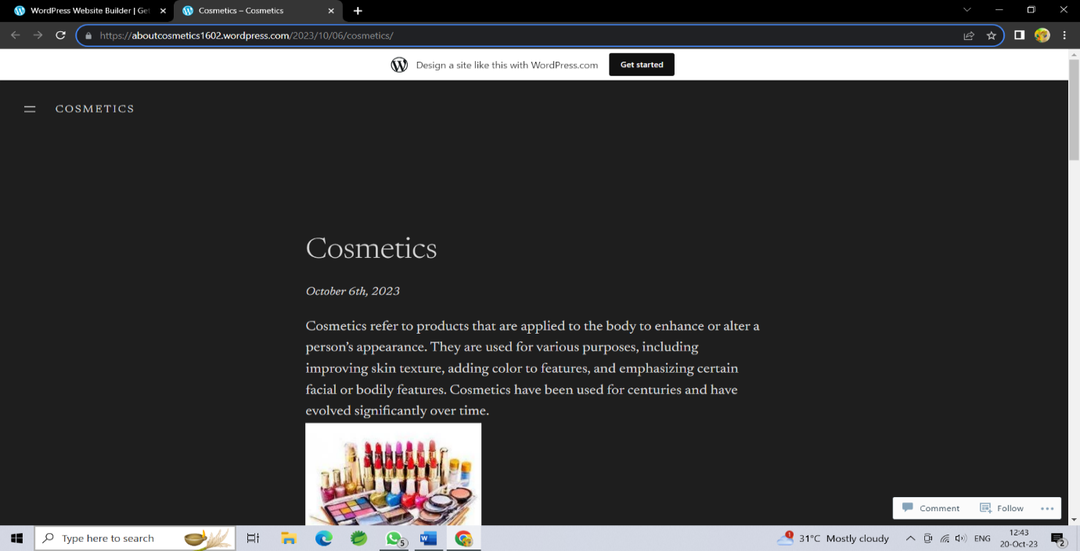

**2**.Create a new facebook page and post one social media poster for your brand.

Link: <https://www.facebook.com/profile.php?id=61550165318681&mibextid=ZbWKwL>

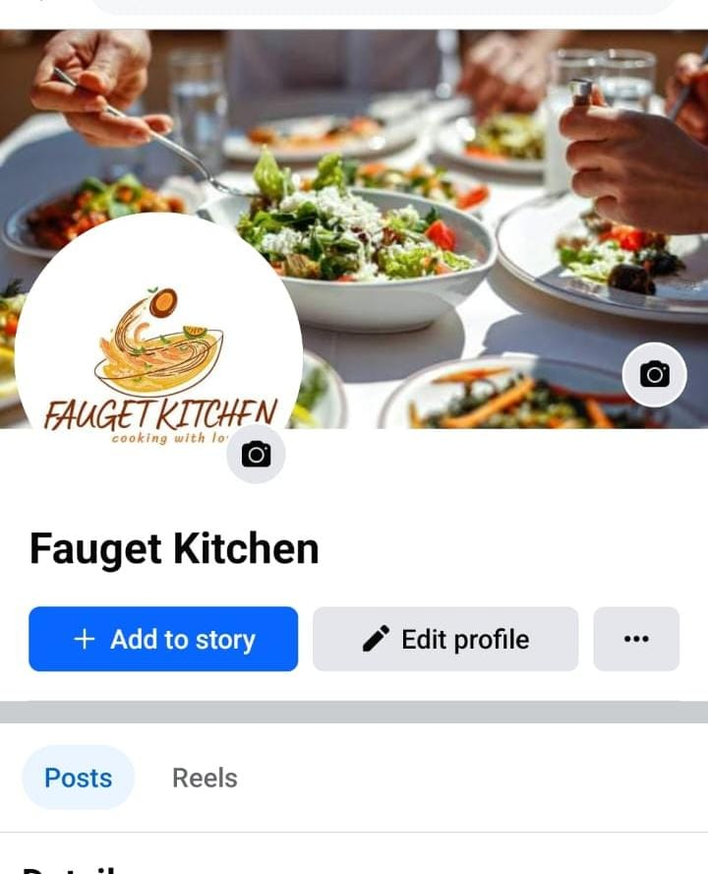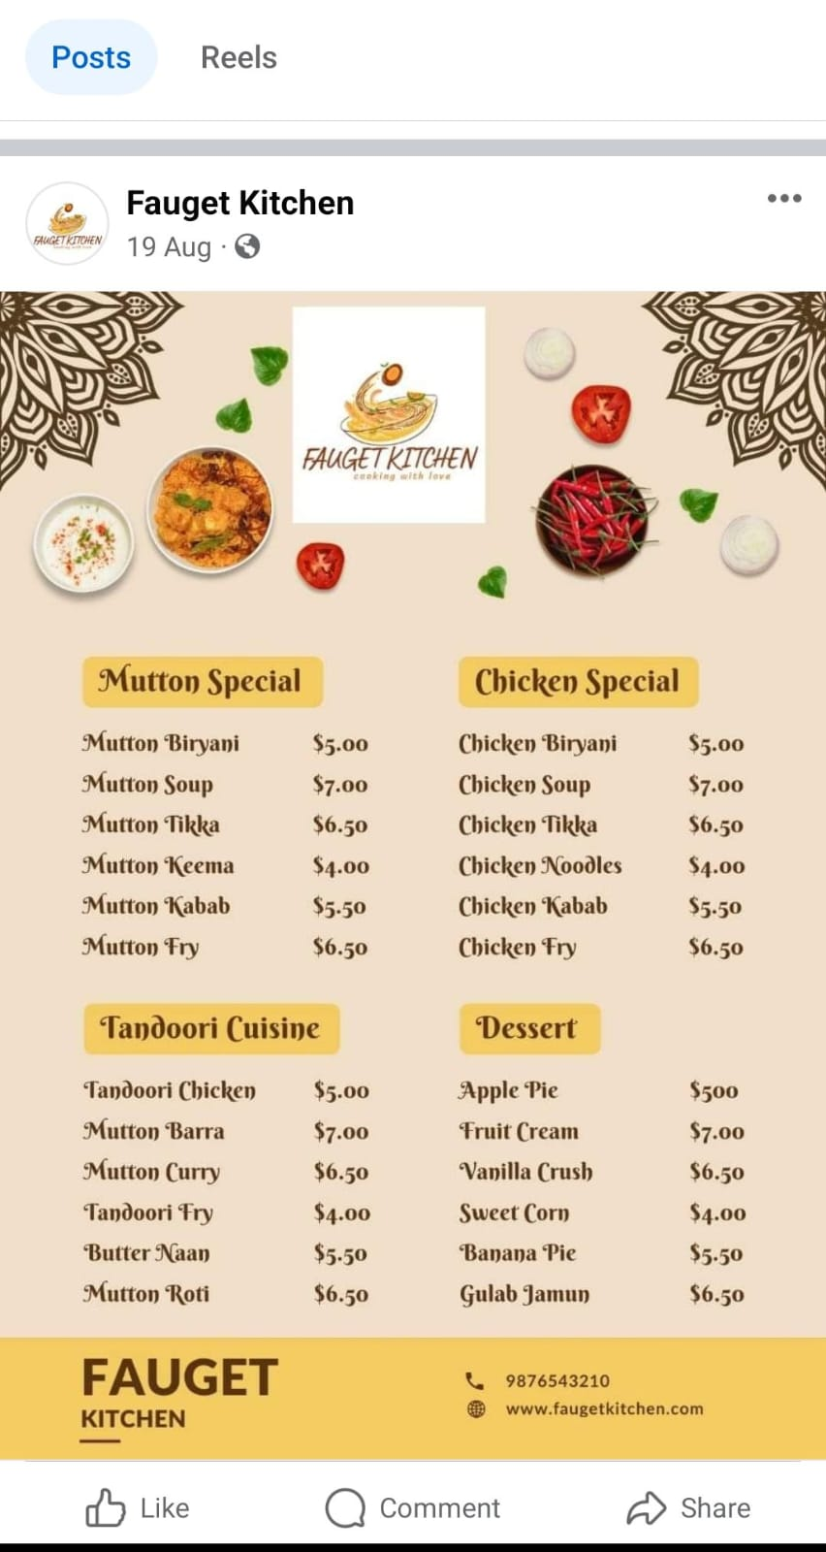

**3**.Create and design a social media advertisement poster using canva

Link:

[https://www.canva.com/design/DAFx5KdNa74/UtI2DuFijAVeSLU5mdUfrQ/edit?utm_content=DAFx5KdNa74&utm_campaign=designshare&utm_medium=link2&utm_source=sharebutton](https://www.canva.com/design/DAFx5KdNa74/LpdKMODNuUe6t_bCS9IOkQ/view?utm_content=DAFx5KdNa74&utm_campaign=designshare&utm_medium=link&utm_source=editor)

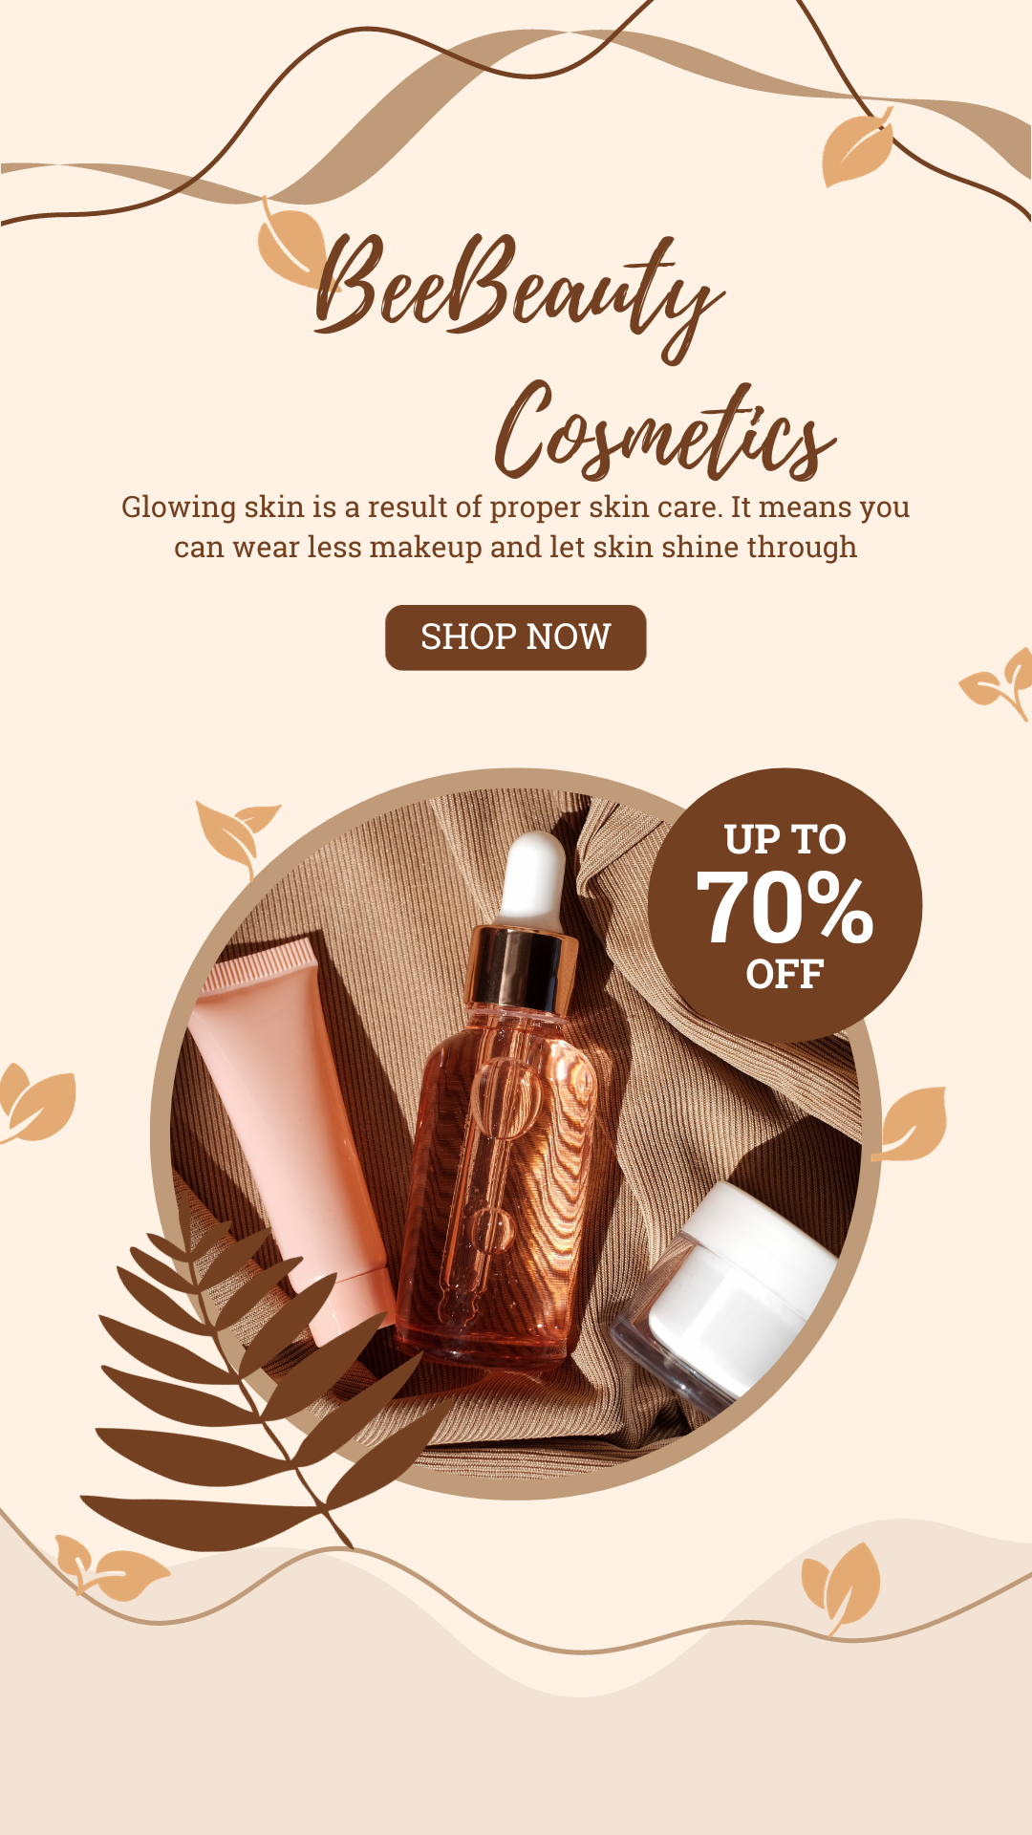

4.Create email newsletter design using MailChimp or canva tool.

Link: <https://www.canva.com/design/DAFtLxIJqtY/nrF0tA6JM56oyGNQ1w3lyA/edit?utm_content=DAFtLxIJqtY&utm_campaign=designshare&utm_medium=link2&utm_source=sharebutton>

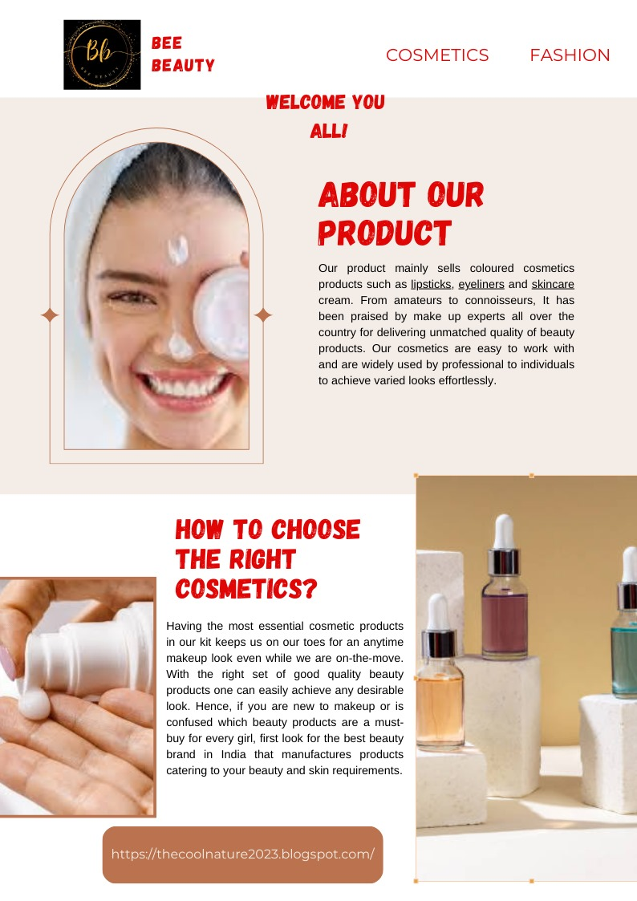

Link: <https://www.blogger.com/blog/post/edit/4906561961716911169/2240001570776986971>

Link: <https://instagram.com/beebeauty1602?igshid=OGQ5ZDc2ODk2ZA==>

